**Data Size vs Throughput**

**128 / 69.3333**

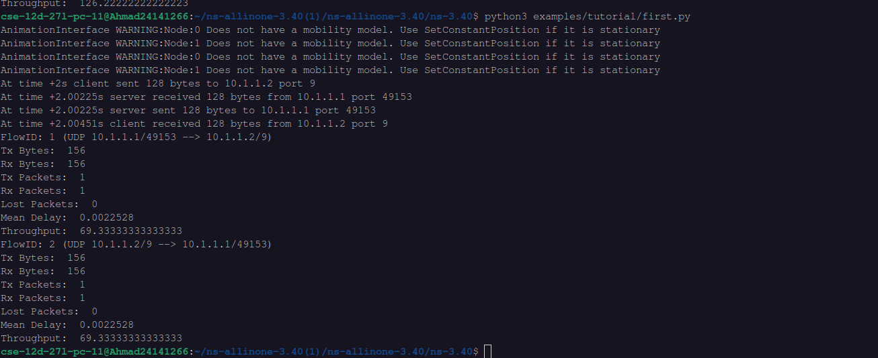

**256 / 126.22222**

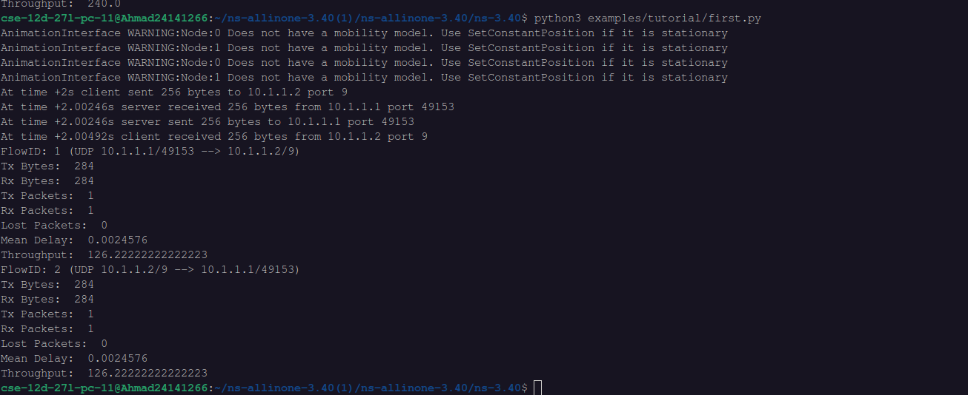

**512 / 240**

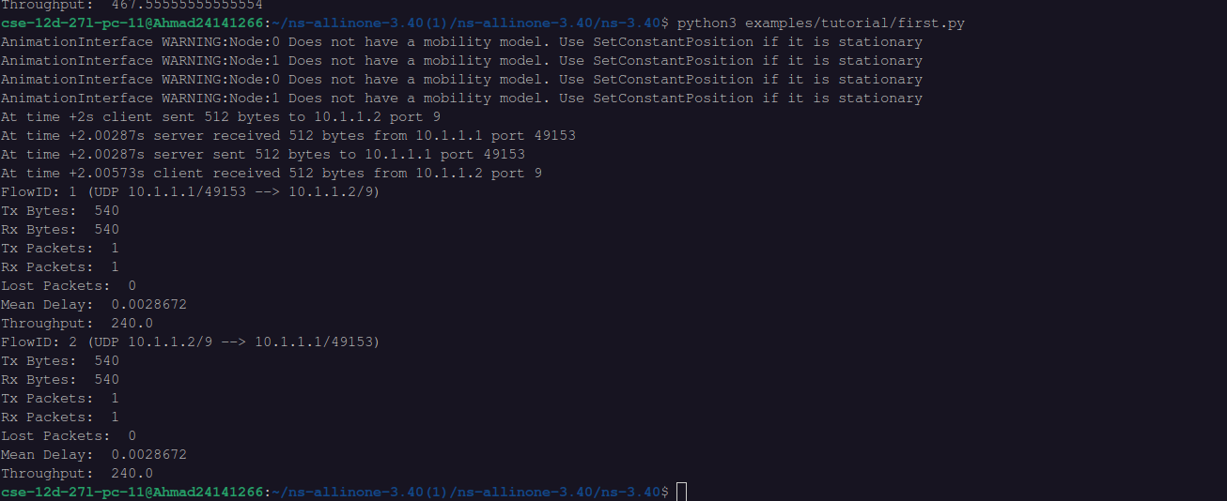

**1024 / 467.555555**

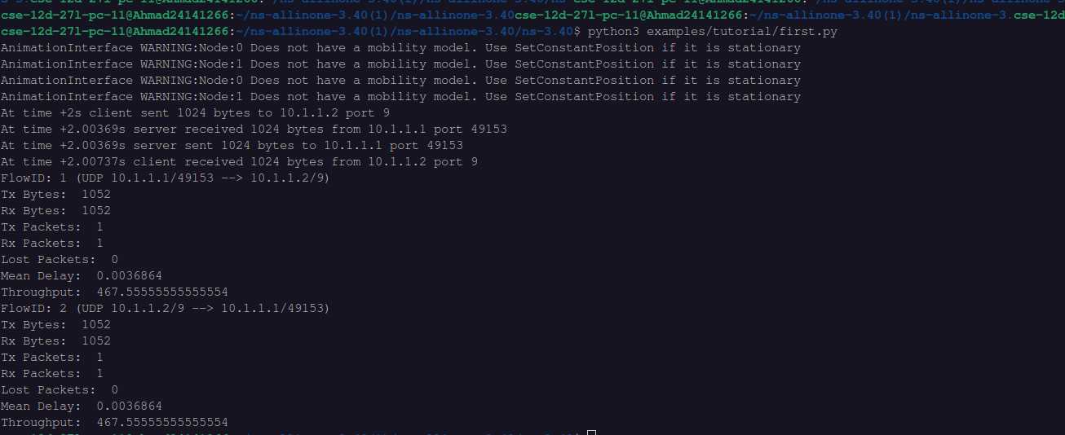

**2048 / 922.66666**

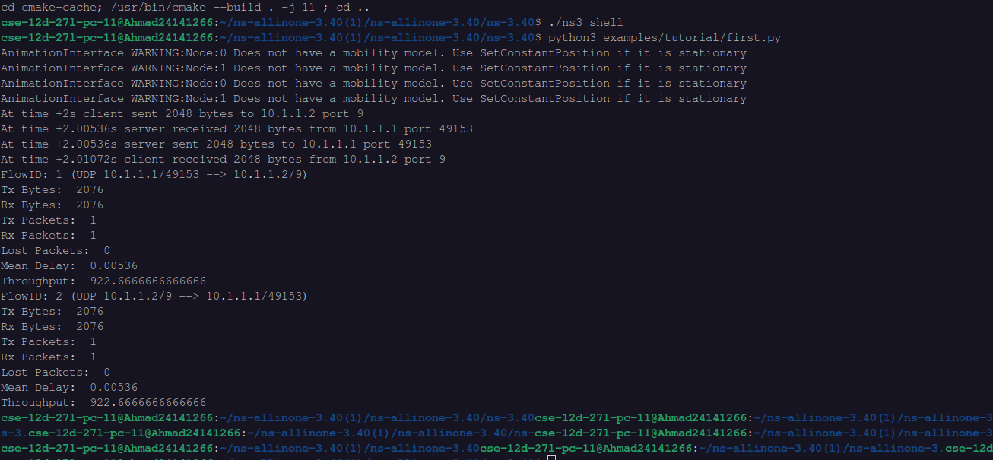

**Graph**

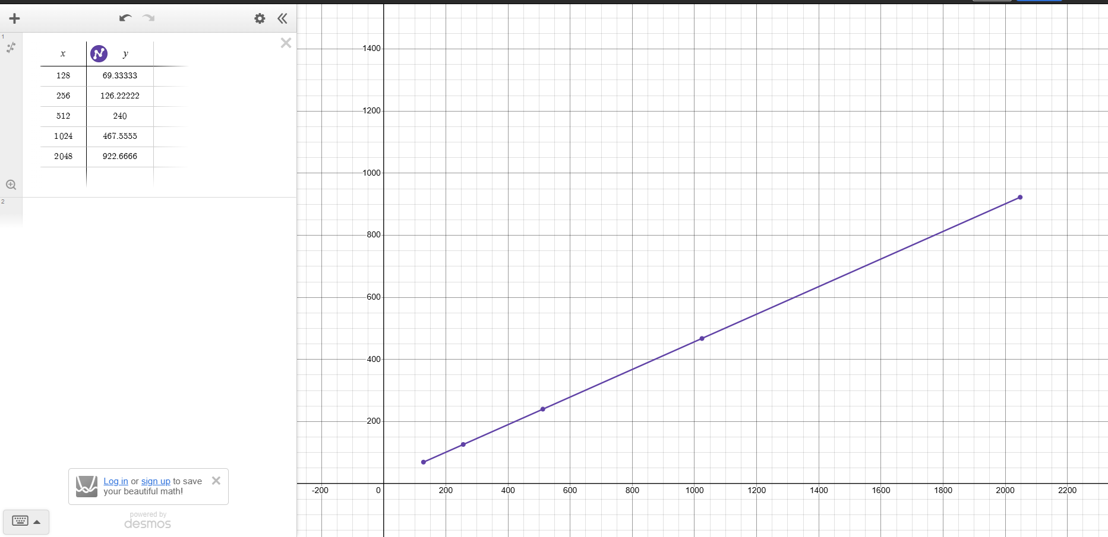

This graph represents the relationship between data size (x-axis) and throughput (y-axis). The data points and fitted line suggest a positive correlation, meaning that as the data size increases, throughput also increases. The trend appears to be approximately linear, indicating that throughput scales proportionally with data size. This could suggest a stable network or system performance where increased data transmission results in a consistent increase in throughput.